# portfolio project (Week 2): MVP

#### Project Schedule

Proposed system would be designed as per the time calculated. Likelihood that timeframes can be met and that this adequate to meet organization's needs.

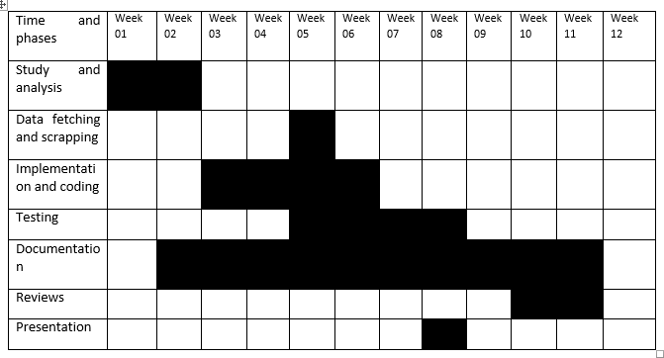

Figure 1‑1 Gantt Chart of Job Search System

* Study and analysis: 1 weeks
* Data fetching and scrapping: 2 weeks
* Implementation and coding: 2 weeks
* Testing: 1 weeks
* Documentation: 4 weeks
* Reviews: 1 weeks
* Presentation: 1 week

### Data Modelling (ER-Diagram)

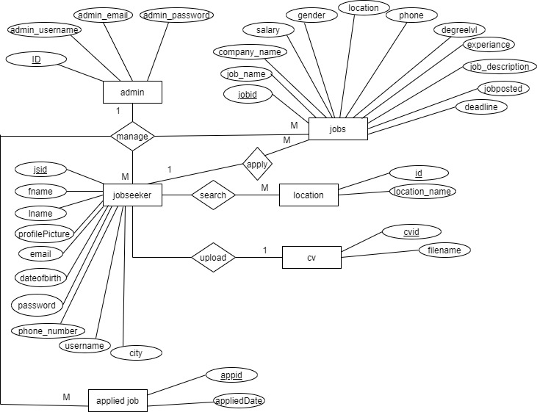

Figure 1‑2 ER Diagram of Job Search System

### Process Modelling (DFD)

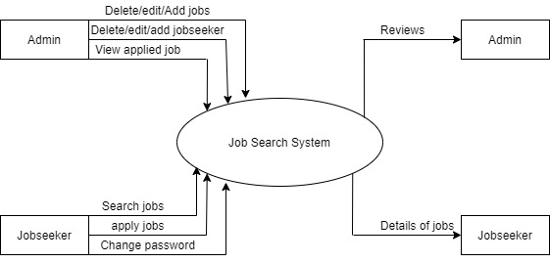

Figure 1‑3 DFD Level 0

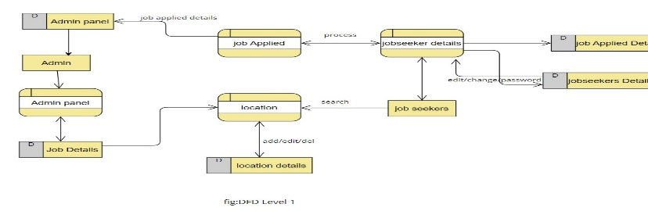

Figure 1‑4 DFD Level 1

## System Design

System design is the process of defining the elements of a system such as the architecture, modules and components, the different interfaces of those components and the data that goes through that system. It is meant to satisfy specific needs and requirements of a business or organization through the engineering of a coherent and well-running system.

### Architectural Design

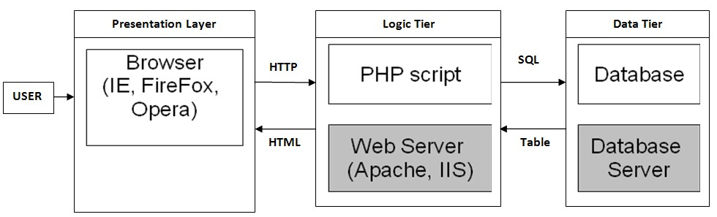

Figure 1‑5 System Design of Job Search System

### Database Schema Design

The general theme behind a database is to handle information as an integrated whole. A database is a collection of inter-related data stored with minimum redundancy to serve single users quickly and efficiently. The general objective is to make information necessary, quick, inexpensive and flexible for the user.

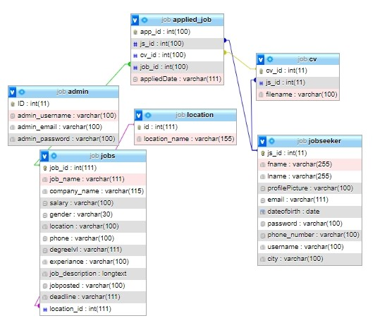

Figure 1‑6 Database Schema of Job Search System

#### Database Tables

Table 1‑1 Admin Table

|  |  |  |  |  |
| --- | --- | --- | --- | --- |
| Field Name | Data Type | Size | Allow Null | Constrain |
| ID | int | 11 | Not | PK |
| admin_username | varchar | 100 | Not |  |
| admin_email | varchar | 100 | Not |  |
| admin_password | varchar | 100 | Not |  |

Table 1‑2 Applied-Job Table

|  |  |  |  |  |
| --- | --- | --- | --- | --- |
| Field Name | Data Type | Size | Allow Null | Constrain |
| app_id | int | 100 | Not | PK |
| js_id | int | 100 | Yes | FK |
| cv_id | int | 100 | Yes | FK |
| job_id | int | 100 | Yes | FK |
| appliedDate | varchar | 111 | Yes |  |

Table 1‑3 CV Table

|  |  |  |  |  |
| --- | --- | --- | --- | --- |
| Field Name | Data Type | Size | Allow Null | Constrain |
| cv_id | int | 11 | Not | PK |
| js_id | int | 11 | Yes | FK |
| filename | varchar | 100 | Yes |  |

Table 1‑4 Jobs Table

|  |  |  |  |  |
| --- | --- | --- | --- | --- |
| Field Name | Data Type | Size | Allow Null | Constrain |
| job_id | int | 111 | Not | PK |
| job_name | varchar | 111 | Not |  |
| company_name | varchar | 115 | Not |  |
| salary | varchar | 100 | Not |  |
| gender | varchar | 30 | Not |  |
| location | varchar | 100 | Not |  |
| phone | varchar | 100 | Not |  |
| degreelvl | varchar | 111 | Not |  |
| experiance | varchar | 100 | Not |  |
| job_description | longtext |  | Not |  |
| jobposted | varchar | 100 | Not |  |
| deadline | varchar | 111 | Not |  |
| location_id | int | 111 | Yes | FK |

Table 1‑5 Jobseeker Table

|  |  |  |  |  |
| --- | --- | --- | --- | --- |
| Field Name | Data Type | Size | Allow Null | Constrain |
| js_id | int | 11 | Not | PK |
| fname | varchar | 255 | Not |  |
| lname | varchar | 256 | Not |  |
| profilePicture | varchar | 100 | Yes |  |
| email | varchar | 111 | Not |  |
| dateofbirth | date |  | Not |  |
| password | varchar | 100 | Not |  |
| phone_number | varchar | 100 | Not |  |
| username | varchar | 100 | Yes |  |
| city | varchar | 100 | Yes |  |

Table 1‑6 Location Table

|  |  |  |  |  |
| --- | --- | --- | --- | --- |
| Field Name | Data Type | Size | Allow Null | Constrain |
| id | int | 11 | Not | PK |
| location_name | varchar | 155 | Not |  |

### Interface Design (UI Interfaces / Interface Structure Diagrams)

All the interface used in my project.

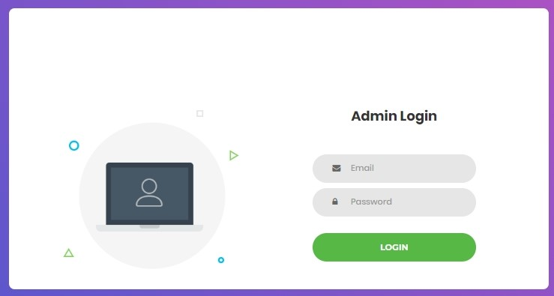

Figure 1‑7 Admin Login

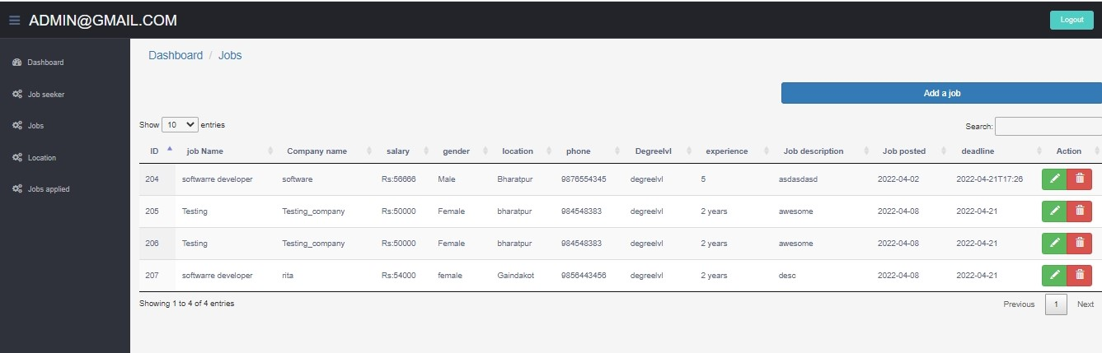

Figure 1‑8 Jobs Details Admin

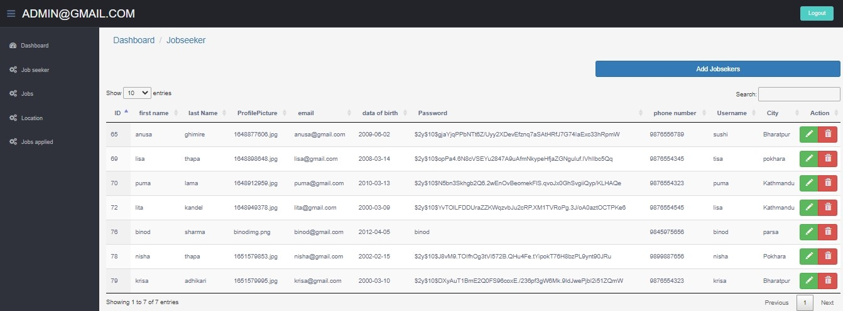

Figure 1‑9 Jobseeker Details Admin

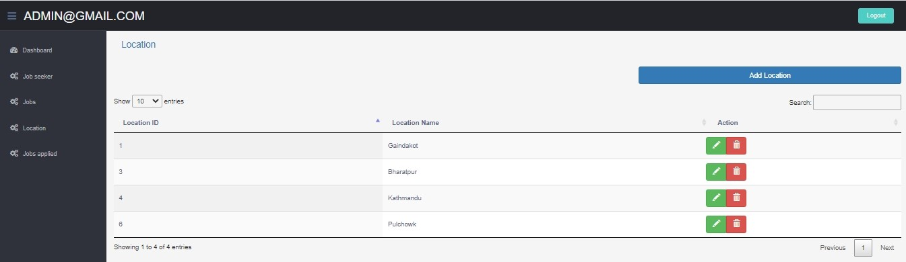

Figure 1‑10 Location Details Admin

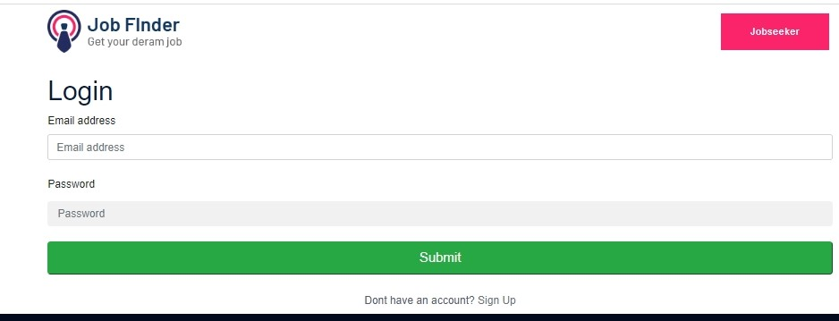

Figure 1‑11 Jobseeker Login

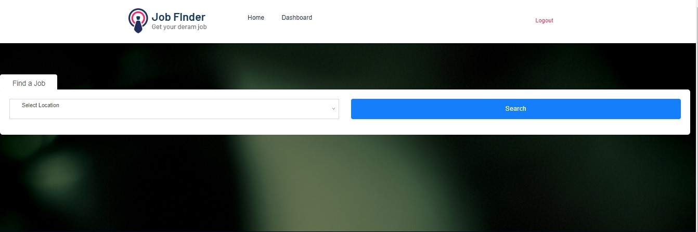

Figure 1‑12 Jobseeker Job Search

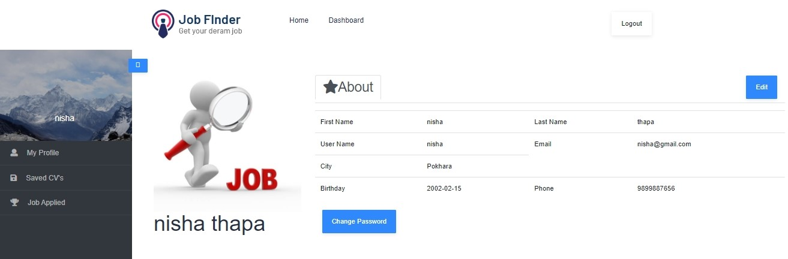

Figure 1‑13 Jobseeker Dashboard

### Physical DFD

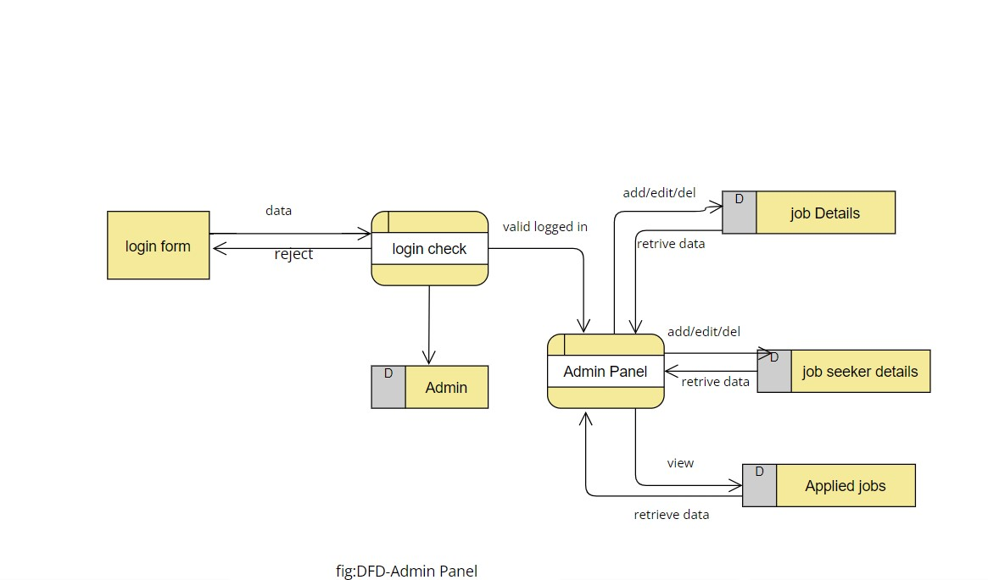

Figure 1‑14 Physical DFD – Admin Panel

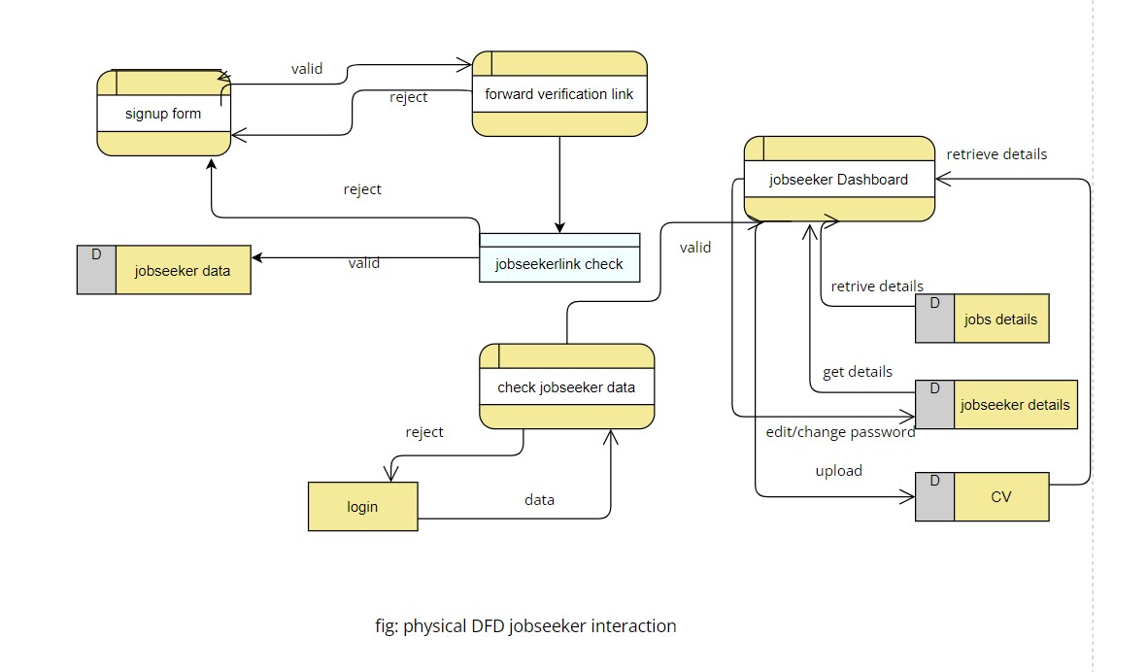

Figure 1‑15 Physical DFD Jobseeker Interaction